Code Review

1. The code Snippet

<!DOCTYPE html>

<html>

    <head>

        <title>The Goal</title>

        <link rel="icon" href="favicon.jpg">

    </head>

    <body>

        <h1> Sharvil Thaker</h1>

        <ol>

            <nav>

                <li><a href="page1.html">My Abilities</a></li>

            </nav>

            <nav>

                <li><a href="page2.html">Achievements</a></li>

            </nav>

            <nav>

                <li><a href="page3.html">Recruitment</a></li>

            </nav>

        </ol>

        <nav>

            <img src="NFLlineup.png" alt="IMAGE1" width="400" height="200">

            <img src="NFLiconimage.webp" alt="IMAGE2" width="300" heigth="400">

            <img src="NFLteamsphoto.jpg" alt="IMAGE3" width="300" heigth="400">

        </nav>

        <nav>

            <li><a href="menulink1.html">Me and My Team Picture </a></li>

        </nav>

        <nav>

            <li><a href="menulink2.html"> The Plan to reach the goal</a></li>

        </nav>

        <nav>

            <li><a href="menulink3.html">About the proffesion</a></li>

        </nav>

        <nav>

            <li><a href="menulink4.html">Education</a></li>

        </nav>

        <br>The external video</br>

        <nav>

            <iframe width="560" height="315" src="https://www.youtube.com/embed/eyKNsoEEpI0"></iframe>

        </nav>

        <br>The school I played in</br>

        <nav>

            <iframe width="560" height="315" src="https://www.youtube.com/embed/NO2veon23Po"></iframe>

        </nav>

    </body>

</html>

1. Current out come

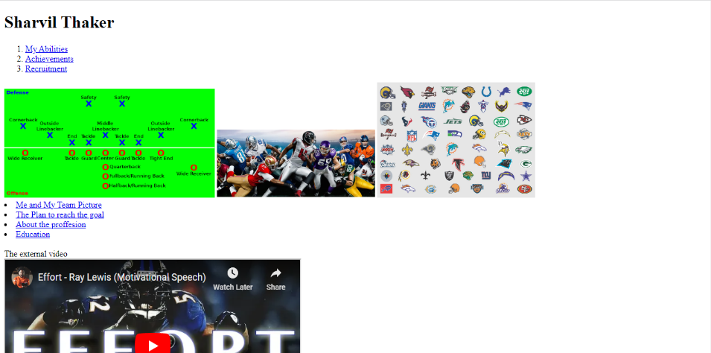

1. In order to achieve my desired result, I would like to add a background using CSS and display the navigation bars on the top right-hand side of the home page (horizontally). I also want to add a horizontal line after my name on the top left side of the page and the top right side for the navigation. Additionally, I would like to change the font colour for the navigations and my name. I have also added style URLs to the center right of the home page to let users know what they can expect.
2. In order to accomplish what I wanted, I first added the style.css file to input all the colours and images and anything else I wanted to decorate or change with visualization in the code. Next, I deleted the two YouTube videos, their headings, the three links above "Education," and because I had added that to my navigation bar, I also deleted all three images. Finally, I started working on the code to create the website I wanted. Here is the code:

<!DOCTYPE html>

<html>

    <head>

        <title>The Goal</title>

        <link rel="icon" href="favicon.jpg">

        <link rel="stylesheet" href="styles.css">

    </head>

    <body class="backgroundIndex">

        <h1> Sharvil Thaker</h1>

        <hr>

        <div id="Navigation">

                <nav>

                    <a href="page1.html">About Myself</a>

                    <a href="page2.html">Achievements</a>

                    <a href="page3.html">Recruitment</a>

                    <a href="menulink4.html">Education</a>

                    <a href="page5.html">Contact me</a>

                </nav>

          </div>

          <div class="container">

                <a href="https://instagram.com/sharvil_thaker?igshid=YmMyMTA2M2Y=" target="_blank">

                  <img src="instaFavicon.png" alt="Instagram logo">

                </a>

                <a href="https://www.tiktok.com/@brownsharu?_t=8aTyJ0YplbB&_r=1" target="_blank">

                    <img src="tiktokfavicon.png" alt="tiktok logo">

                </a>

            </div>

        </div>

        <nav class="TheQuote">

            <p>

                “Success isn't measured by money or power or social rank. Success is measured by your discipline and inner peace.” -Mike Ditk

            </p>

        </nav>

    </body>

</html>

For the style.css I have included:

.backgroundIndex {

    background-image: url(NFLbackroudImage2.jpg);

    background-repeat: repeat;

}

#Navigation{

    position: fixed;

    top: 0;

    right: 0;

    padding: 30px;

}

  #Navigation a:hover{

    background-color: green;

}

#Navigation a {

    display: inline-block;

    margin-left: 10px;

    color: rgb(235, 157, 12);

    text-decoration: none;

    font-weight: bold;

    font-size: 20px;

    width: 120px;

}

.TheQuote{

    color: white;

    font-family: Arial, Helvetica, sans-serif;

    font-size: 20px;

    margin: 30px;

    float: left;

    max-width: 500px;

    font-weight: bold;

    font-style: italic;

}

.container {

    display: flex;

    flex-direction: column;

    position: absolute;

    top: 50%;

    right: 0;

    transform: translateY(-50%);

    margin: 10px;

  }

  .container img {

    width: 40px;

    height: 40px;

    padding: 15px;

  }

Container: displaying the style URL’s which is Instagram and Tik-Tok.

The quote: displaying the quote that I have imputed on the left side of the page.

Navigation, navigation a: hover, and navigation a: This displays the navigation on the top right-hand side of the page with hover, font, and in horizontal.

And final backgroudIndex: To display the background picture that I have chosen.

1. Present the new outcome of the code:

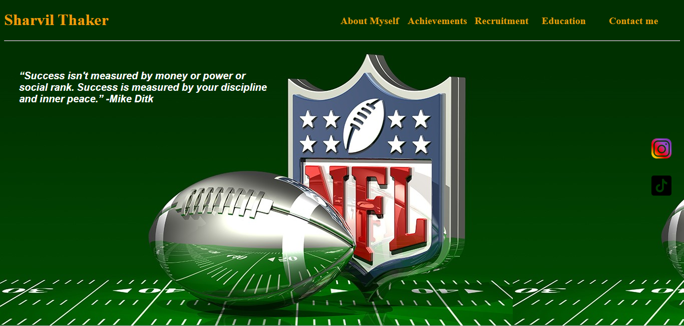

**Second piece**

1. The code Snippet:

<!DOCTYPE html>

<html>

    <head>

        <title>The Goal</title>

        <link rel="icon" href="favicon.jpg">

    </head>

    <body>

        <h1>Polyglot Languages</h1>

        <ol>

            <li>English</li>

            <li>Gujarati</li>

            <li>Punjabi</li>

            <li>Hindi</li>

            <li>Urdu</li>

        </ol>

        <h1>My favourite religious music</h1>

        <ol>

            <audio controls src="Hai Katha Sangram Ki  Star Plus Mahabharat Official Title Song With Lyrics.mp3"></audio>

        </ol>

        <h1>KEY SKILLS</h1>

        <ol>

            <li>Leadership</li>

                <li>Problem solving</li>

                <li>Listening</li>

                <li>Time Management</li>

                <ul>

                    <li>I am very competitive person which helps me to work harder</li>

                    <li>I know how to control my emotions in any situation</li>

                </ul>

                <li>Teamwork</li>

                <li>Confident</li>

                <li>Optimistic</li>

                <li>Self-management</li>

            <li>Fast learner</li>

        </ol>

        <h1>Sports I Play</h1>

        <ol>

            <li>Basketball</li>

            <li>Football</li>

            <li>Soccer</li>

            <li>Cricket</li>

        </ol>

        <h2>Here is me in a high school football uniform</h2>

        <a href="page4.html">

            <img width="70" height="70" src="Mypictureuniform.jpg">

        </a>

        <p>Click to open</p>

    </body>

</html>

1. Current outcome:

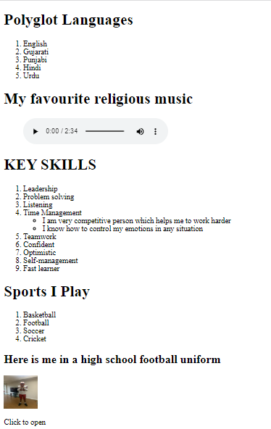

1. I want to create a grid for this, and inside of that grid, I want to add a table to make it look clear. I also want to change the background colour to make it look nice. In addition, I want to change every aspect of the format I've already established, including the fonts, sizes, and page orientation. The purpose is to make people stick on that page to read about me.
2. To fix this problem, I have created same input as before creating style.css adding the representation to display the code:

<body class="backgroudpage1">

      <div class="Grid">

        <div class="item1">

            <table>

                <tr>

                  <th>Polyglot Languages</th>

                  <td>

                    <ol>

                      <li>English</li>

                      <li>Gujarati</li>

                      <li>Punjabi</li>

                      <li>Hindi</li>

                      <li>Urdu</li>

                    </ol>

                  </td>

                </tr>

                <tr>

                  <th>My favourite religious music</th>

                  <td>

                    <audio controls src="Hai Katha Sangram Ki  Star Plus Mahabharat Official Title Song With Lyrics.mp3"></audio>

                  </td>

                </tr>

                <tr>

                  <th>KEY SKILLS</th>

                  <td>

                    <ul>

                      <li>Leadership</li>

                      <li>Problem solving</li>

                      <li>Listening</li>

                      <li>Time Management</li>

                      <li>I am very competitive person which helps me to work harder</li>

                      <li>I know how to control my emotions in any situation</li>

                      <li>Teamwork</li>

                      <li>Confident</li>

                      <li>Optimistic</li>

                      <li>Self-management</li>

                      <li>Fast learner</li>

                    </ul>

                  </td>

                </tr>

                <tr>

                  <th>Sports I Play</th>

                  <td>

                    <ol>

                      <li>Basketball</li>

                      <li>Football</li>

                      <li>Soccer</li>

                      <li>Cricket</li>

                    </ol>

                  </td>

                </tr>

              </table>

            </div>

            <div>

For the style sheet:

.Grid{

    display: grid;

    grid-template-columns: auto auto;

    row-gap: 50px;

    column-gap: 30px;

    justify-content: center;

    margin: 60px;

}

.backgroudpage1{

    background-image: url(NFLpictureGolden.jpg);

    background-repeat: no-repeat;

    background-size: cover;

    text-align: center;

}

.Grid table {

    background-color: brown;

    border-collapse: collapse;

}

th, td {

    border: 2px solid;

    padding: 6px;

}

.Grid img{

    float: right;

    width: 300px;

    height: 400px;

    border-radius: 20px;

}

.Grid p{

    color: white;

    width: 300PX;

}

.Grid ol{

    font-style: italic;

    font-weight: bold;

}

.Grid ul{

    font-style: italic;

    font-weight: bold;

}

.Grid th{

    font-weight: bold;

    font-style: italic;

    text-decoration: underline;

}

.item1 {

    grid-row: 1/span 2;

}

* Grid: to display the format in grid, template columns, the size of the row and columns and to represent it in the center of the page.
* To achieve the goal to create a good background first I created the class as usual in the body and then to edit then text, headings, editing both the list there where eight other class I have to create to display all of them for their different representation, and at the end I have inputted the grid-row element in item1, grid-row is used to specify the row position and span of a grid item within a grid container. In the value 1/span 2, 1 specifies the starting row position of the grid item, and span 2 specifies that the grid item should span two rows. So, grid-row: 1/span 2; means that the grid item should start at the first row of the grid container and span across two rows.

1. Present the new outcome of the code:

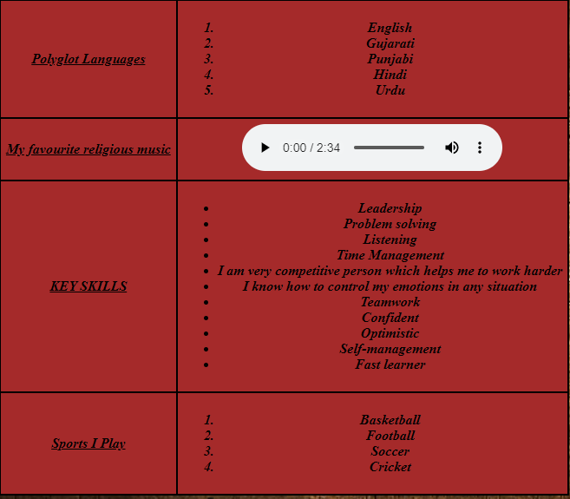

**Third piece**

1. The code Snippet:

<body>

        <h1>Journey Achievemnts</h1>

        <table>

            <tr>

                <td><b>CURRICULAR</b></td>

                <td><b>School</b></td>

            </tr>

            <tr>

                <td>Most Valuable Player (MVP)</td>

                <td>LAHSBasketball team 2019</td>

            </tr>

            <tr>

                <td>Offensive Player of the year</td>

                <td>LAHS Basketball team 2020</td>

            </tr>

            <tr>

                <td>Valuable Service Award</td>

                <td>LAHS 2020</td>

            </tr>

            <tr>

                <td>Best Project Certificate</td>

                <td>LAHS 2022</td>

            </tr>

        </table>

    </body>

1. Current outcome:

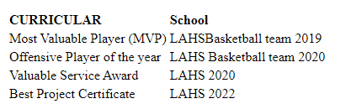

1. I want to completely modify the format of the above display, which is extremely plain and basic with no colours, rows, columns, borders, or backgrounds. Instead, I want to present this with eye-catching graphics and a transparent backdrop so that it will blend in with the background of its page.
2. To fix this issue, I constructed a border around the table with row and column margins that reflect the white space and lines between the words. To make the border of the table even darker and brighter, I used the colour "gold.":

<body class="backgroudpage2">

        <h1>Journey Achievemnts</h1>

        <div>

        <table class="Table">

            <tr>

                <td id="A"><b>CURRICULAR</b></td>

                <td id="B"><b>School</b></td>

            </tr>

            <tr>

                <td>Most Valuable Player (MVP)</td>

                <td>LAHSBasketball team 2019</td>

            </tr>

            <tr>

                <td>Offensive Player of the year</td>

                <td>LAHS Basketball team 2020</td>

            </tr>

            <tr>

                <td>Valuable Service Award</td>

                <td>LAHS 2020</td>

            </tr>

            <tr>

                <td>Best Project Certificate</td>

                <td>LAHS 2022</td>

            </tr>

        </table>

    </div>

    </body>

For the style sheet:

.Table {

    color: white;

    margin: 20px;

    padding: 25px;

    border: 5px solid gold;

    float: left;

    border-radius: 10px;

}

#A{

    color: white;

    font-weight: bold;

    font-style: italic;

    font-size: 20px;

    font-family: Arial, Helvetica, sans-serif;

}

#B{

    color: white;

    font-weight: bold;

    font-style: italic;

    font-size: 20px;

    font-family: Arial, Helvetica, sans-serif;

}

* I have made id selectors for both of them in order to update just the table heads and no other elements, and I have represented those selectors in the style sheet.
* Border, padding, margins, colour, side, and border-radius are all represented by the table class. The graphics of the table seem pretty excellent as a result of this adjustment.

1. Present the new outcome of the code.

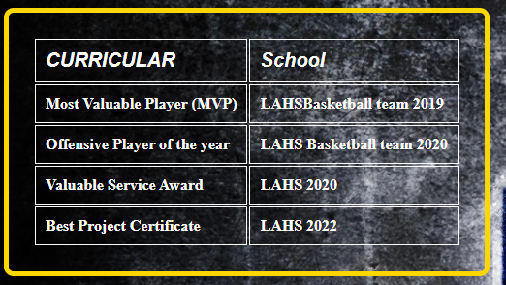

**Fourth piece**

1. The code Snippet:

<video width="400" heigth="400" controls>

            <source src="sharvil.mp4">

        </video>

1. Current outcome:

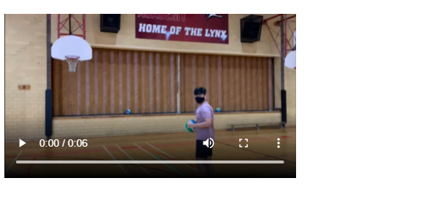

1. I have no issues with the way the video is being displayed, but I would like to modify it with a border and padding to match the table and the appearance of the specific webpage in order to match the colours and visuals of the table that I described in "Third piece".
2. The table in “Third piece” is In the same webpage as the video, so the video input are in the same body, only the modification version is different in style sheet:

table ~ video {

    border: 2px goldenrod solid;

}

This will make the video's border 2 px solid and make it goldenrod in colour, which matches the colour of the table to symbolize the single visual on the webpage.

Present the new outcome of the code:

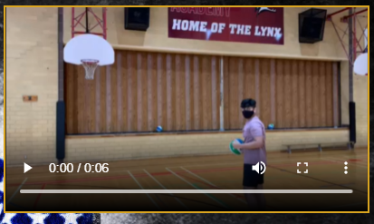

**Fifth piece**

1. The code snippet:

 <body>

        <h1>What is the recuritment proccess of NFL</h1>

        <ul>

            <li>Free-agent signings</li>

            <li>trading their players for players from other teams</li>

            <li>drafting college players who have declared themselves eligible for the NFL draft</li>

        </ul>

    </body>

1. The current outcome:



1. This page is very plain and uninteresting with no colour or graphics. I want to update the colour and content of the information provided regarding the NFL recruitment process as well as add a colorful backdrop that complements the home sites.
2. To fix this issue, I used the style sheet to create a backdrop and the class in the style sheet to modify the text's colour, the only thing that is changed in the html file is that I have added and named the class in the body tag, here is the code in the style.css:

.backgroundpage3{

    background-image: url(NFLbackgroudImage3.jpg);

    background-repeat: repeat;

}

.backgroundpage3 li{

    color: rgb(206, 231, 93);

}

1. Present the new outcome of the code:

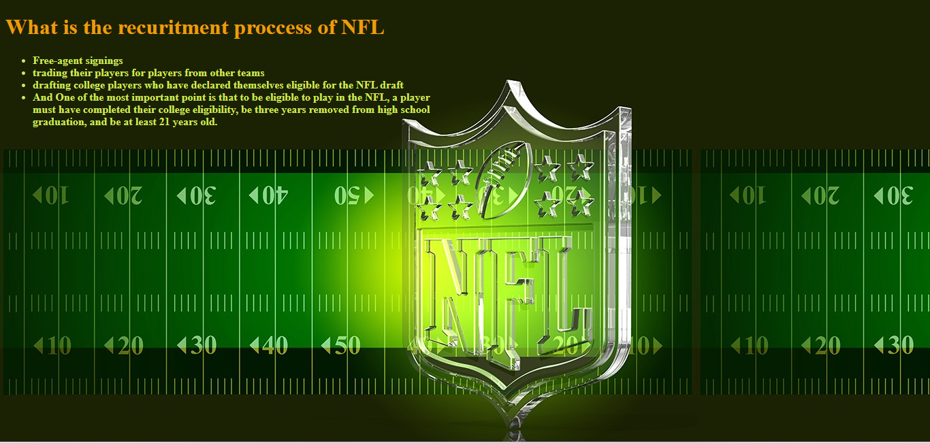

* I have changed the webpage title based on the webpage information and need, I have done this because this was one of the important feedback I have got from the marking of assignment one.